Yanbu Industrial College
Computer Science and Engineering Department
CS381 Web Application Development

Phase 4: Integration, Security and Final Submission
Project Title: Student Feedback System

Student Name 1 | Aseel Azoni
Student ID 1 | 441500260
Student Name 2 | Hanan Alanazi
Student ID 2 | 441500457
Instructor | Mr. Muhammad Rafiq and Ms. Mai
Academic Year | 1447-1448 / 2025-2026

Table of Contents
1. Problem Description
2. Description of System
3. Phase 4 Integration Summary
4. Security Implementation
5. Final Application Features
6. Database and Login Credentials
7. System Output Screenshots
8. Video Walkthrough Plan
9. Challenges
10. Future Improvements
11. Conclusion

1. Problem Description
The chosen service module is Student Feedback System. The system helps Yanbu Industrial College students submit feedback about courses, instructors, grading, exams, campus facilities, and services. The main problem addressed by this system is that feedback needs to be collected, organized, reviewed, and followed up by administrators in one secure web application.

2. Description of System
The Student Feedback System contains two main roles: student and admin. Students can register, login, submit feedback, view their own feedback, edit their own feedback, and delete their own feedback. The admin can login, view all feedback, see dashboard statistics, update the status of feedback, and delete feedback records when needed.

3. Phase 4 Integration Summary
- Frontend pages were connected with PHP backend pages.
- PHP pages were connected to the MySQL database using PDO.
- Student and admin role flows were integrated.
- CRUD functions were tested through the final application.
- Navigation links were checked for both student and admin users.
- The final package includes README instructions, database file, source code, and defense preparation files.

4. Security Implementation
Security Item | Implementation
Input Validation | Required fields, email format, category values, and status values are validated on the server side.
SQL Injection Prevention | All database operations use PDO prepared statements with placeholders.
Password Security | User passwords are saved using password_hash() and verified using password_verify().
Session Authentication | Sessions are used to keep the user logged in and identify the user role.
Role-Based Access Control | require_login() and require_admin() protect pages from unauthorized access.
XSS Prevention | Output is escaped using htmlspecialchars() through the e() helper function.
CSRF Protection | POST forms include a CSRF token generated in the session and verified before processing.
Final Cleanup | The direct password reset script was removed from the final submission package.

5. Final Application Features

Student Features
- Register new account
- Login and logout
- Submit feedback
- View own feedback
- Edit own feedback
- Delete own feedback
- View feedback status

Admin Features
- Login as admin
- View all submitted feedback
- View total number of students
- View total feedback count
- View pending feedback count
- Update feedback status
- Delete feedback records

6. Database and Login Credentials
Database name: student_feedback_system
Database file: DB/database.sql
Role | Email | Password
Admin | admin@yic.edu.sa | 123456
Student | aseel@student.yic.edu.sa | 123456
Student | hanan@student.yic.edu.sa | 123456

7. System Output Screenshots
Insert final screenshots in this section after testing the application locally.

Home Page
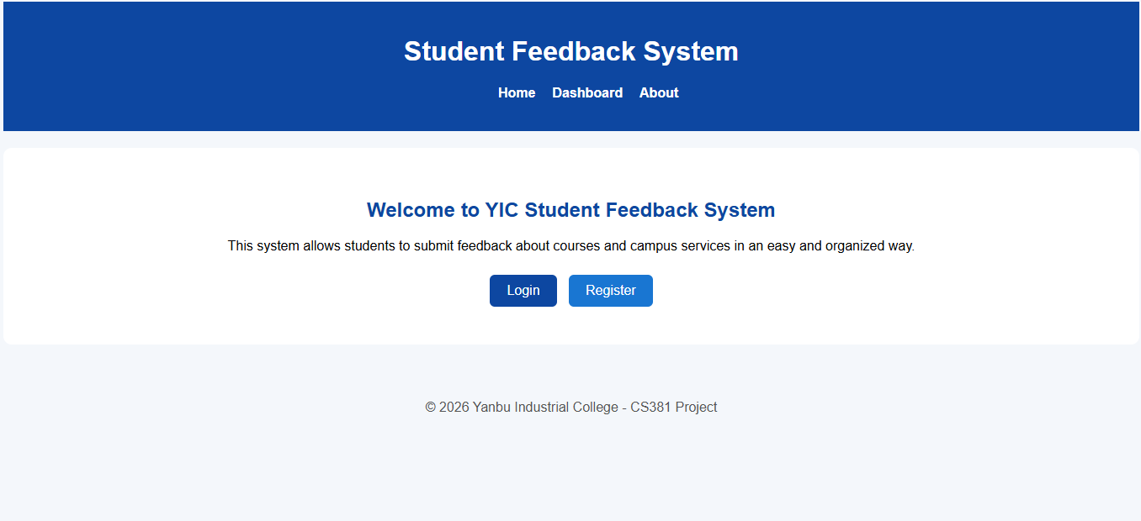

Login Page
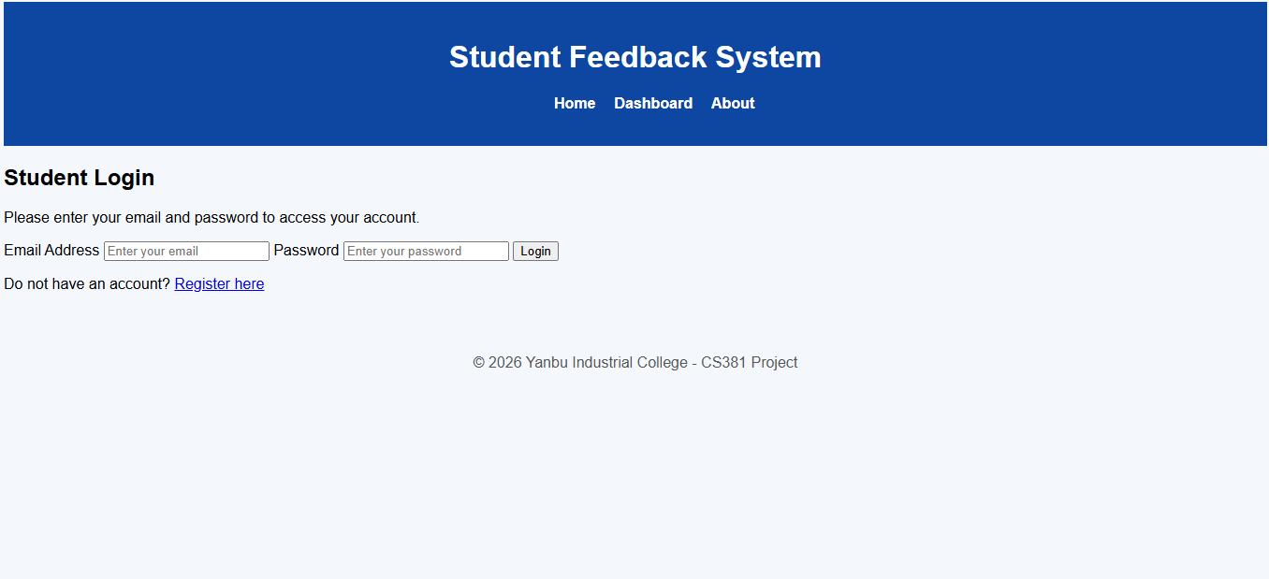

Register Page
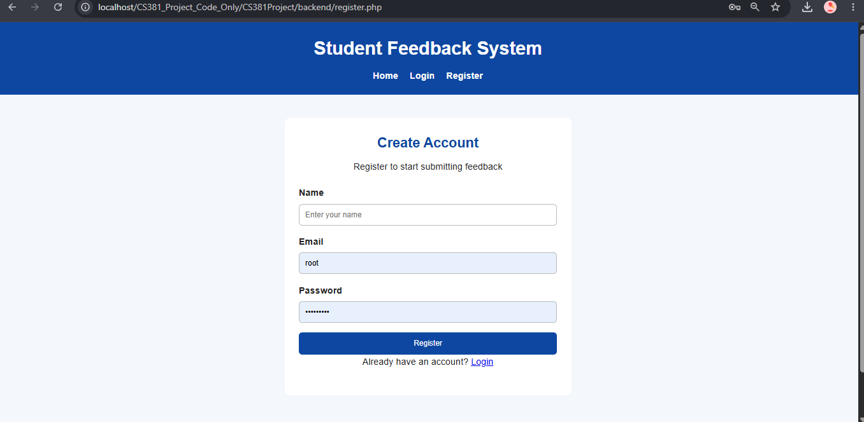

Student Dashboard
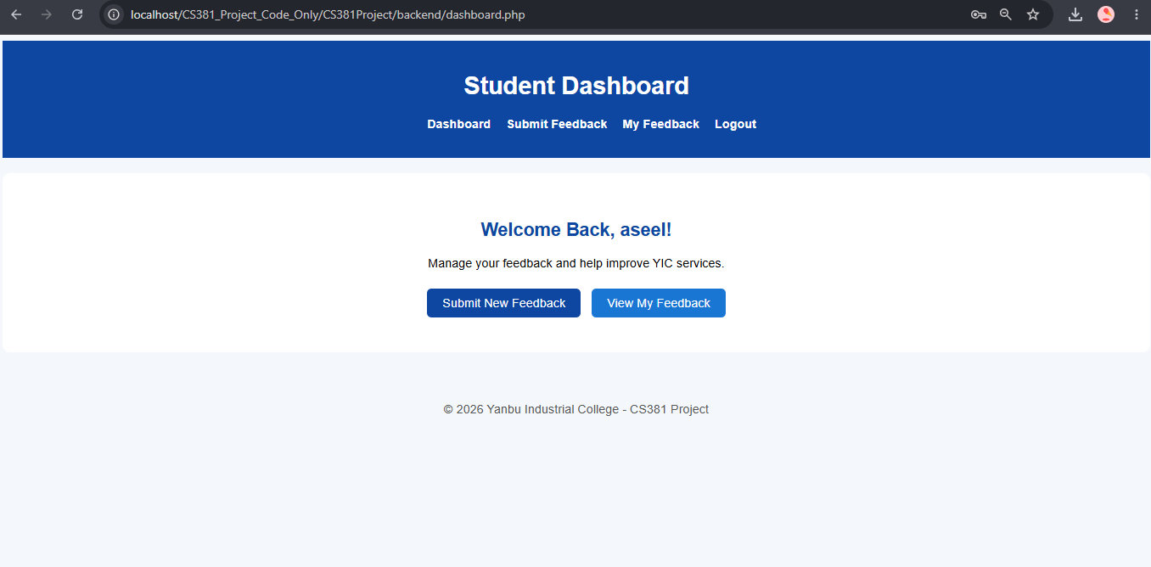

Submit Feedback Page
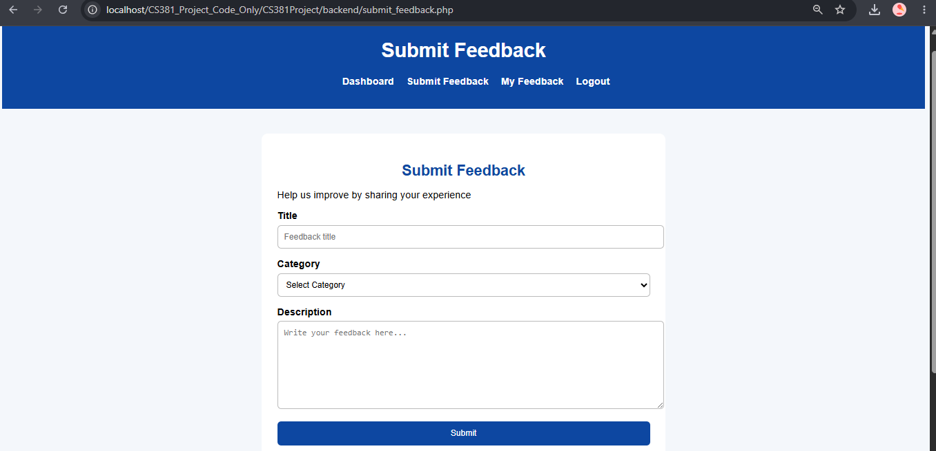

My Feedback Page
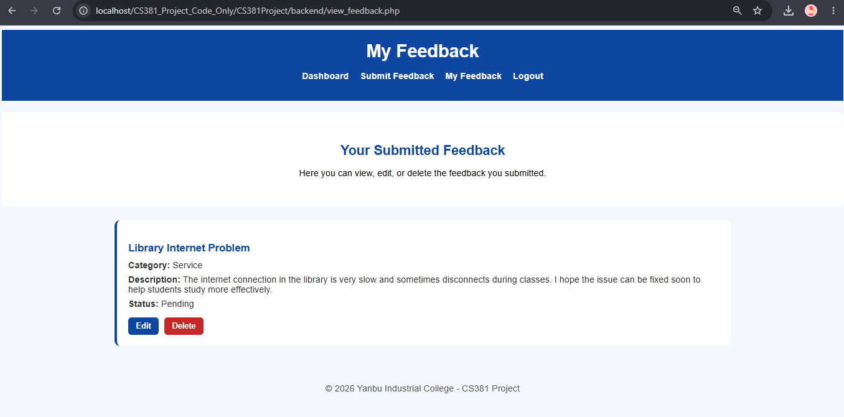

Admin Dashboard
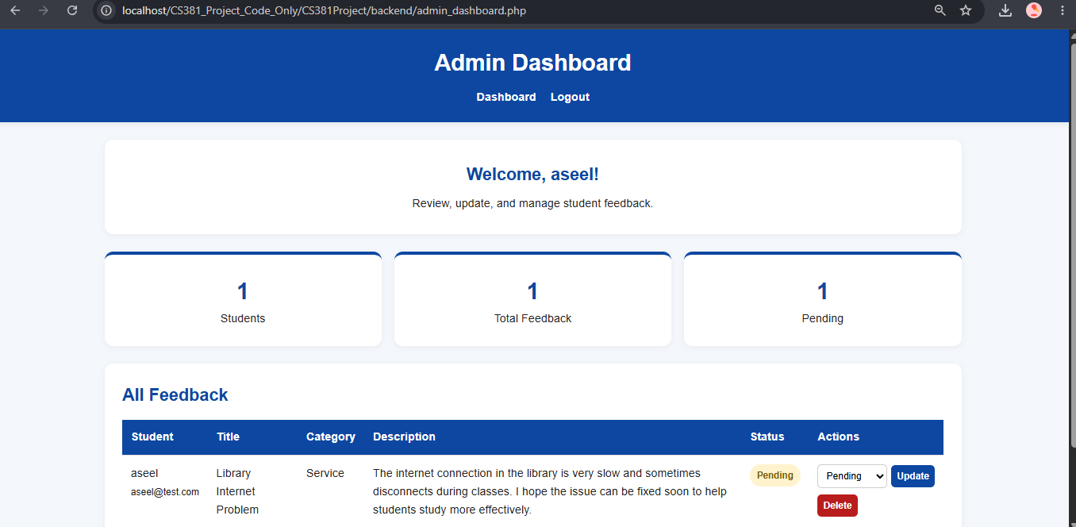

Database Tables in phpMyAdmin
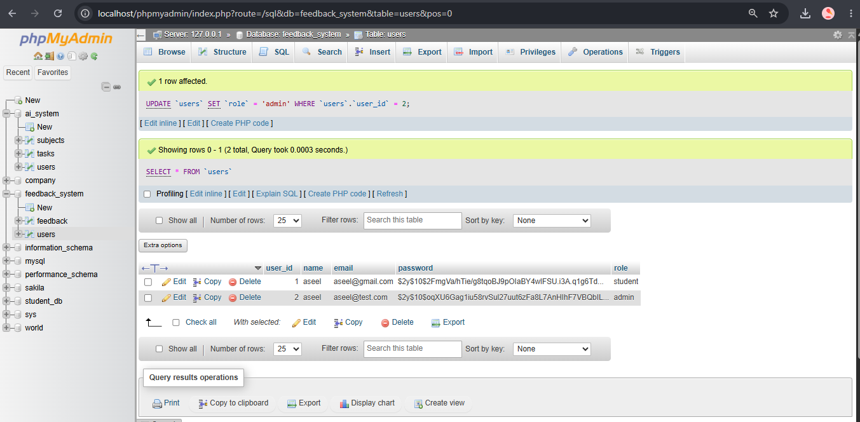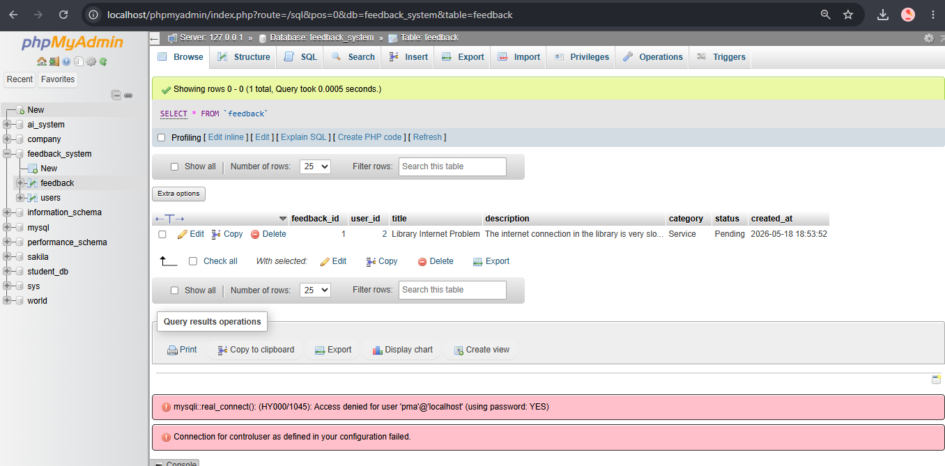

8. Video Walkthrough Plan
- Open home page and introduce the project.
- Login as student.
- Submit new feedback.
- View, edit, and delete student feedback.
- Logout from student account.
- Login as admin.
- Show dashboard statistics.
- Update feedback status.
- Explain security features briefly.
- End the video.

9. Challenges
- Connecting the frontend pages with PHP backend files.
- Managing two different roles with different permissions.
- Making sure students can only access their own feedback.
- Keeping the code secure while using plain PHP without frameworks.
- Testing all CRUD operations before final submission.

10. Future Improvements
- Add email notifications when admin updates feedback status.
- Add search and filter options in the admin dashboard.
- Add charts for feedback categories and statuses.
- Allow students to attach files or screenshots to feedback.
- Add pagination for large numbers of feedback records.

11. Conclusion
The final Student Feedback System is a complete working web application that integrates frontend pages, PHP backend, MySQL database, authentication, role-based access, CRUD operations, and security features. The system meets the Phase 4 requirements by providing a polished final application, security implementation, setup documentation, and a clear walkthrough plan for demonstration and defense.

